Name: ____________________________________ Class: _____________



JURONG PIONEER JUNIOR COLLEGE
JC2 Preliminary Examination 2024

GEOGRAPHY 9173/01
Higher 2 10 September 2024
Paper 1 3 hours
INSERT

READ THESE INSTRUCTIONS FIRST
This insert contains all the Resources referred to in the questions.

This document consists of 8 printed pages.
[Turn over
[Turn over
[Turn over
Resource 1 for Question 1

Global distribution of proven oil reserves

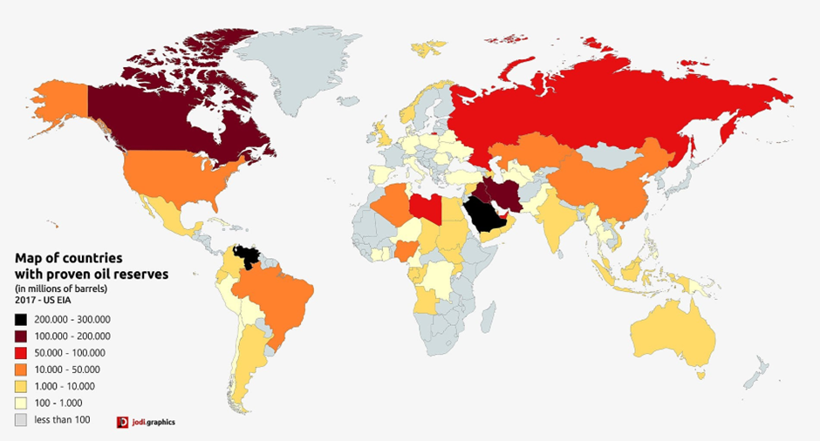

Resource 2A for Question 1
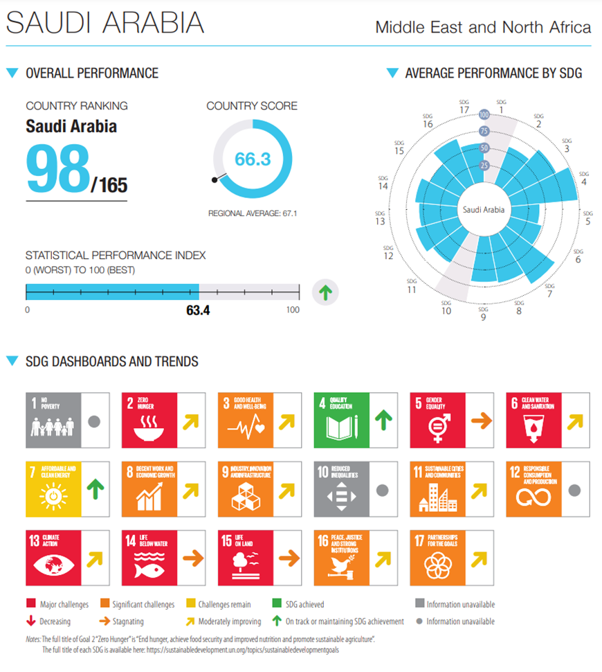
Saudi Arabia’s performance in Sustainable Development Goals
Sustainable Development Goals
No Poverty
Zero Hunger
Good Health and Well-being
Quality Education
Gender Equality
Clean Water and Sanitation
Affordable and Clean Energy
Decent Work and Economic Growth
Industry, Innovation, and Infrastructure
Reduced Inequality
Sustainable Cities and Communities
Responsible Consumption and Production
Climate Action
Life Below Water
Life on Land
Peace, Justice, and Strong Institutions
Partnerships for the Goals

Resource 2B for Question 1

Canada’s performance in Sustainable Development Goals

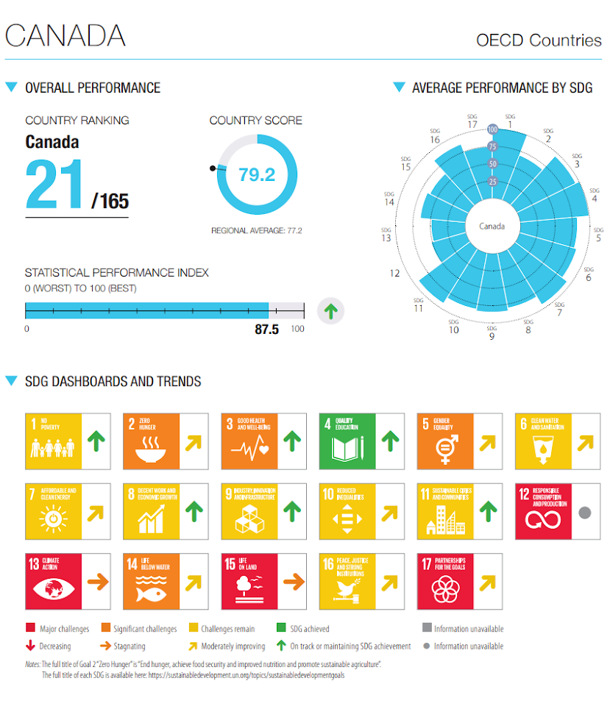
Sustainable Development Goals
No Poverty
Zero Hunger
Good Health and Well-being
Quality Education
Gender Equality
Clean Water and Sanitation
Affordable and Clean Energy
Decent Work and Economic Growth
Industry, Innovation, and Infrastructure
Reduced Inequality
Sustainable Cities and Communities
Responsible Consumption and Production
Climate Action
Life Below Water
Life on Land
Peace, Justice, and Strong Institutions
Partnerships for the Goals

Resource 3 for Question 1
Share of Saudi Arabia’s GDP, by economic activity, 2021
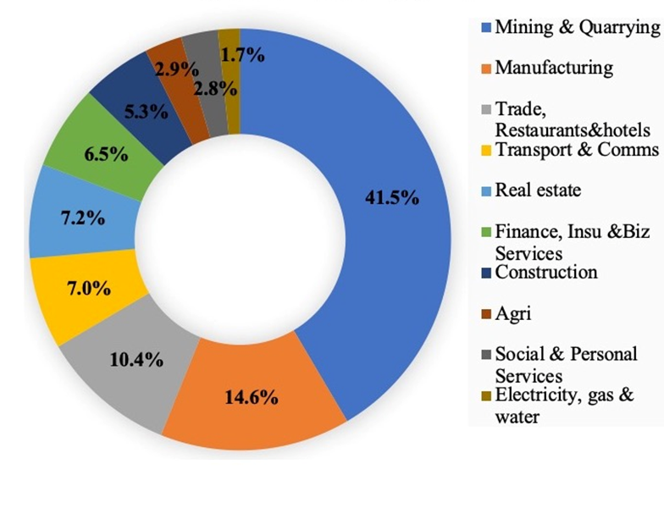

Resource 4 for Question 2

Flood risk map of the Niger River

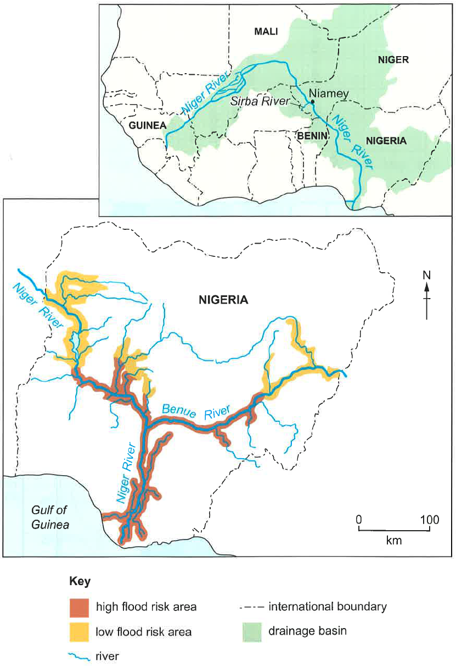

Resource 5 for Question 2

Flood risk at Talle on the Sirba River, a tributary of the Niger River

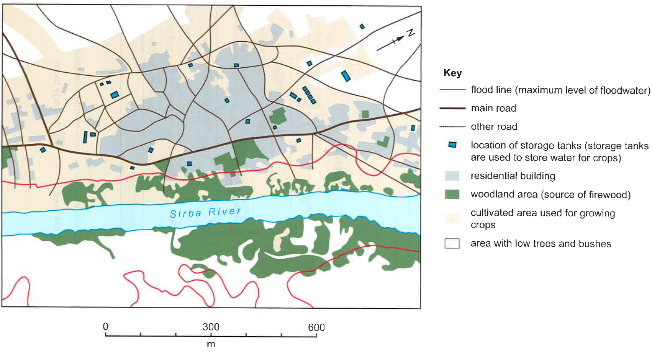

Resource 6 for Question 2

Location of Niger Delta

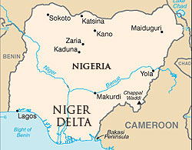
Gulf of Guinea

Resource 7 for Question 2

An oil spill in the Niger Delta

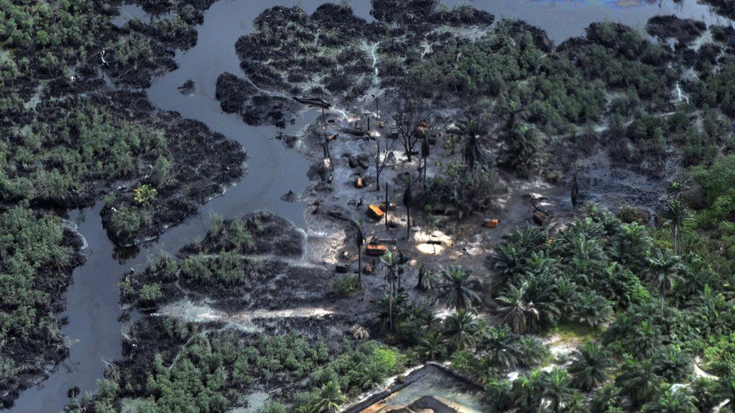

End

